Check this at the end. Also, yeb2a check “Digital Logic and Design Interview Preparation” book attached in the same folder.

Logic Design and Digital Electronics
- Why do we avoid using latches?
Answer:
- Being level sensitive, a latch gives the place and route tool less flexibility to meet timing.
- Glitches could cause the output of a latch to change, again causing timing issues.
Further illustration on each point:
- Watch video 1.
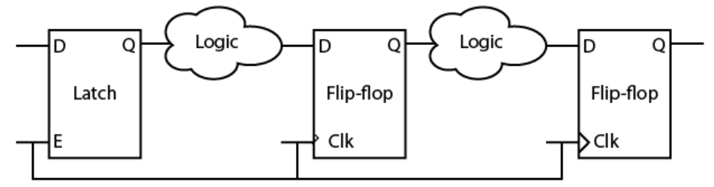
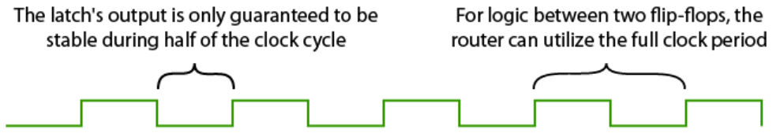

- Watch video 2

- If you are a project manager for an IP vendor (ex. ARM), and a customer is asking for signoff corners 1.5x slower than usual. What is the impact on the IP (area, power, timing, development time, how much you charge the customer).
Answer:
Signoff corners abta2 ma3naha en el cells el delay beta3ha ba2a akbar, y3ny ma3naha en el customer bey2olak en el chip el haya5odha menak de hateshtaghal fi harsh environment, aktar men el enta fel tabe3y betsana3 3leeh el chip beta3tak. Fa el hy7sl:
1) Area: bema en el denya ba2et 1.5x slower, fa keda momken ye7sal setup violations fi ba3d el amaken w bel taly a7tag sa3et-ha eny asta5dem cells ykoon leha driving strength akbar 3ashan still a meet timing. Thus, driving strength akbar yeb2a area akbar.
2) Power: momken badal ma asta5dem cells be driving strength akbar asta5dem cells be Vth a2al. W Vth a2al ma3naha leakage current akbar and hence power akbar.
3) Timing: akeed el customer lama y2oly en el denya ba2et 1.5x slower da hay5aly meeting el timing as3ab.
4) Development time: 3ashan a3od a7el el mashakel bta3t el timing el ba2et nateget en el denya ba2et 1.5x slower, akeed ha5od development time akbar men el tabe3y fel chip de.
5) Cost: akeed hazawed 3al customer cost zeyada la2eno 5alany a2ady wa2t akbar fel chip beta3to.

If you have received a chip after fabrication and you began testing it but it is not working, what can you do?
If the chip was designed to operate at 100 MHz for example, try to operate it at 80 MHz. If it worked, then it was a setup time violation. What if we had only a single oscillator of 100 MHz? then try to increase the supply voltage so that the gates’ delay decrease and hence achieve the same effect of decreasing the clock frequency. Tyb 3amalt el faat da w mashtaghaletsh n3ml eh? allaho a3lam! enta w 7azak hato3od tegarab b2a, mafeesh systematic way. 5aly balak en mafeesh 7aga te catch el hold violation, lw fi f3ln hold violation 5alas shokran lazem ne respin (i.e. nesana3 tany).

Check “Flip_Flops_And_Gate_Conversions” file.

Verilog
(Questions can be found in “VERILOG INTERVIEW QUESTIONS WITH ANSWERS.pdf”).

What is the difference between:
1) wire [7:0] mem
2) wire mem [7:0]
Answer:
wire [7:0] mem declares an 8-bit vector.
wire mem [7:0] declares 8 vectors, each of 1-bit width.
Dayman efteker el gomla de: "el width beyegy abl el depth". Y3ny lw katabna el size abl el name yeb2a width, lw katabna el size b3d el name yeb2a depth. El
gomla de hatsa3dak bardo tefteker el 2D array, la2en fel 2D array bardo ben2ol:
wire [7:0] mem [127:0]
This creates a 2D array of 128 vectors, each of 8-bit width.

- Is there a synthesis problem with the following code due to missing c in the sensitivity list?
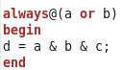
Answer:
No, because the synthesis tool does not care about sensitivity lists in case of combinational logic.

Further illustration:
Ah e7na nesena nekteb c fel sensitivity list, however el hayetla3 fel a5er howa and gate da5el 3leeha a & b & c w 5areg d 3ady 5ales. Da haye3mel bs moshkela fel simulation, y3ny we7na lesa benekteb 3la modelsim lw ro7na 3amalna rasamna el waveforms w ghayarna c, hanal2y f3ln d mesh betetghayar 3ashan c mesh maktoba fel sensitivity list, laken da fel simulation bs, fel synthesis el tool hate3mel el e7na 3ayzeno 3ady 5ales, w da topic mash-hor esmo simulation and synthesis mismatch (more on this here). Tab da sababo eh? en aslan el sensitivity list de in case of combinational logic heya just for simulation purposes, laken aslan el tool wala betbos 3al sensitivity list de (again, in case of combinational logic only). 7ata enta fakar fiha keda, lw e7na delwa2ty olna la2 el hayetla3 fel a5er mesh and gate zy mana 3ayez, w enama hayetla3 7aga t5ly en lama el c tetghayar d matetghayarsh 3ashan c mesh fel sensitivity list. Tab oly eh el 7aga de? Mesh hatla2y! la2en be basata mafeesh 7aga esmaha keda.

__________________________________________________________________________________________________

- Write a Verilog code for a gray counter.

Answer: in the link below. Simply, you write a normal incrementing counter, and you just do some xoring operations on its bits.

Power Aware Design

Static Timing Analysis
- Setup time and hold time, meen bey limit el maximum operating frequency?

Answer: Tsetup decides the maximum operating frequency, while Thold is not concerned about the operating frequency.
More illustration: in setup analysis, we are concerned with 2 clock edges; the launching edge and the capturing edge. While in hold analysis, we are concerned only with 1 clock edge. Fa fel setup analysis el duration maben el 2 clock edges betefre2, y3ny el Tperiod betefre2, w 3ashan keda zaharet fel equation. Fa hanla2y en fih lower limit 3al Tperiod de besabab el setup time, y3ny upper limit 3al operating frequency. Thus, setup time decides the maximum operating frequency! on the other hand, bema en el hold time beyeshtaghal 3and 1 clock edge, fa howa mesh fare2 m3ah aslan el clock period, w 3ashan keda mazaharetsh fi equation el hold.

----------------------------------------------------------------------------------------------------------------------------------------------------------

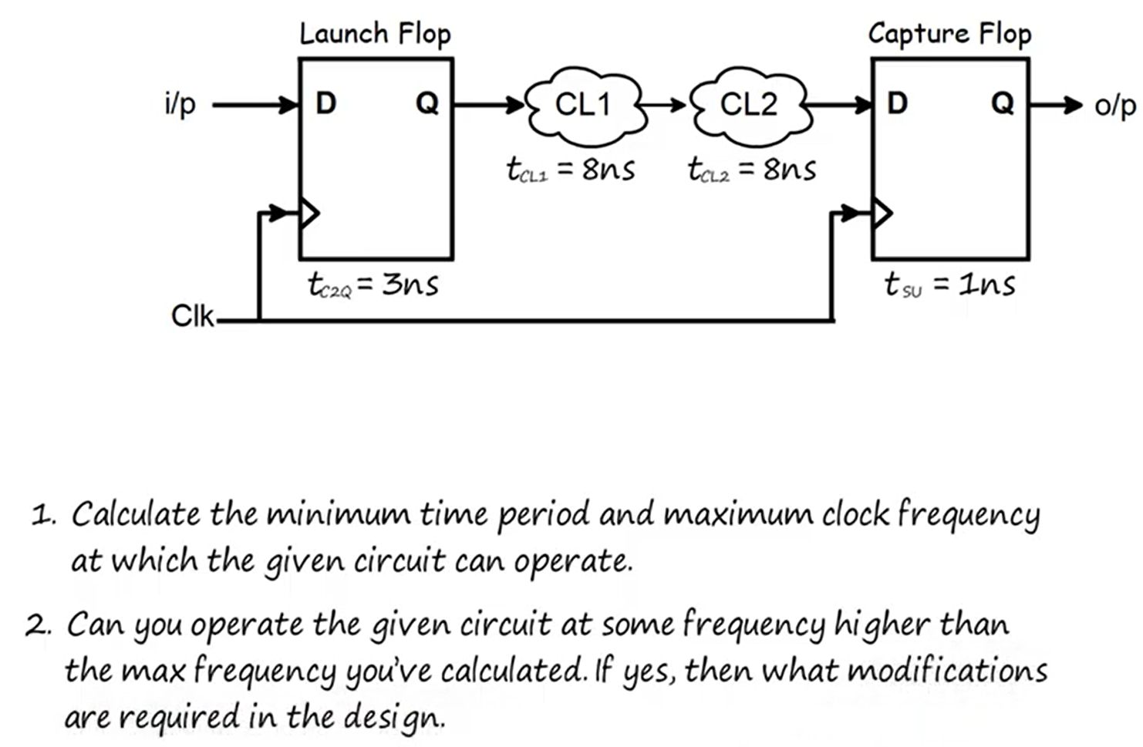
Assume the signal propagating from CL1 to CL2 is a single-bit data. Also assume any additional gates (and, mux, etc.) that you wish to use has a delay of 1 ns.

1.

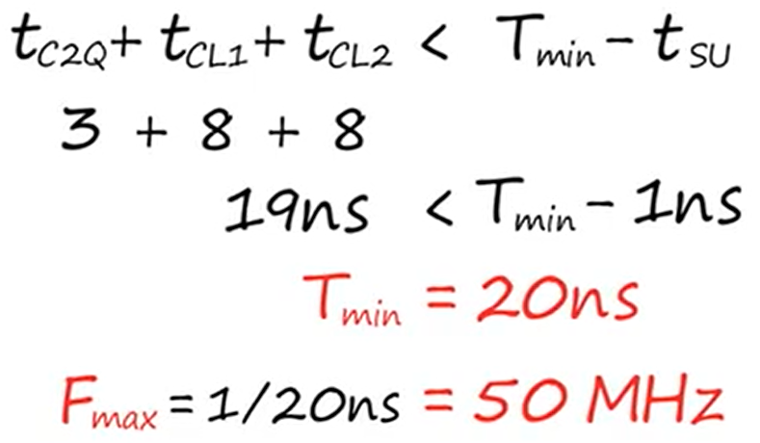

2. Tab3an momken te2ol el fixes el e7na 3arfenha lel setup violation, el heya enena ne2alel delay el comb. logic be enena nesta5dem cells with higher driving strength (i.e. larger W), or less Vth, aw ne play with the skew. However, howa hena bey2olak modify el circuit, y3ny mesh hanghayar el combinational logics el mawgoda wala el clock line.
Solution 1:
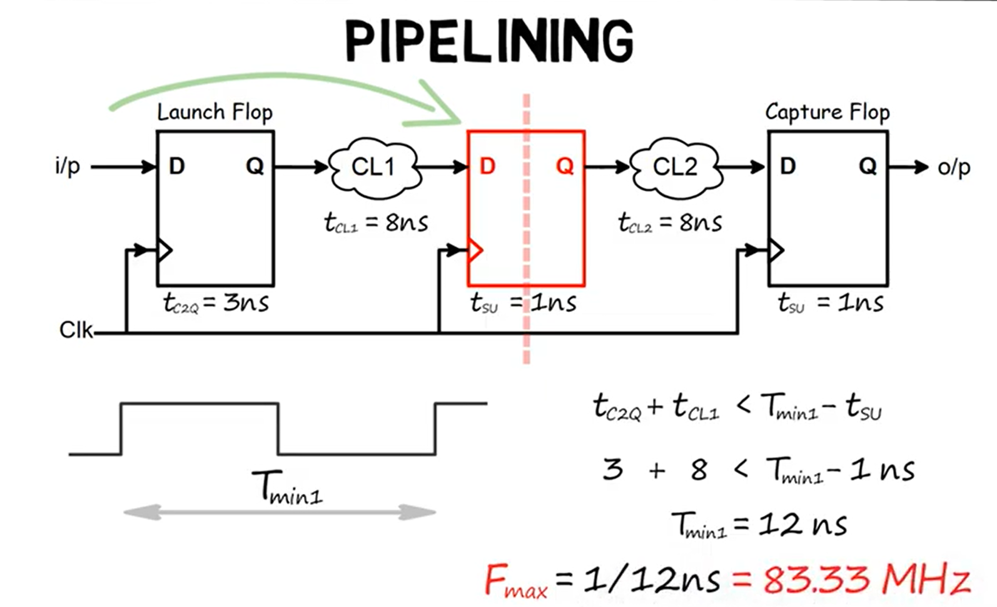
Badal ma el signal el ray7a men el launch flop lel capture flop ta5od el 2 combinational logics el fel nos 1 shot keda, la2 5aleha teraya7 fel nos fi flip flop b7ees el signal matshofsh delay kebeer within 1 clock period. Now recalculate the maximum frequency hatla2eha f3ln zadet 3an 50 MHz w ab2et 83.33 MHz.
Solution 2:
Since the signal propagating from CL1 to CL2 is a single-bit data, so it is either 0 or 1. So, instead of waiting for this signal to propagate from through CL1 in 8 ns, then waiting for another 8 ns to propagate through CL2, la2 e7na ne3mel duplication le CL2 logic da, w mara neda5al 3leeh 1 w mara neda5al 3leeh 0 b7ees ykoon el output beta3o 3la tool gahez. El output b2a bta3 CL1 da neda5alo 3la selection line bta3 mux el inputs bto3o howa el CL2 w heya da5elaha 1 w heya da5elaha 0. Fa keda badal ma hastana 8 ns fi CL2, hastana 1 ns bs fel mux.
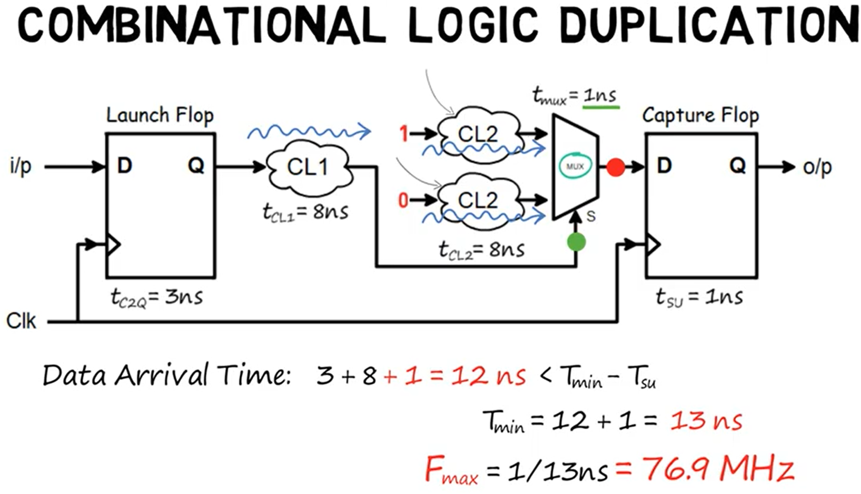
Pipelining drawback: increased latency (extra clock cycle).
Comb. logic duplication drawback: increased area.
----------------------------------------------------------------------------------------------------------------------------------------------------------

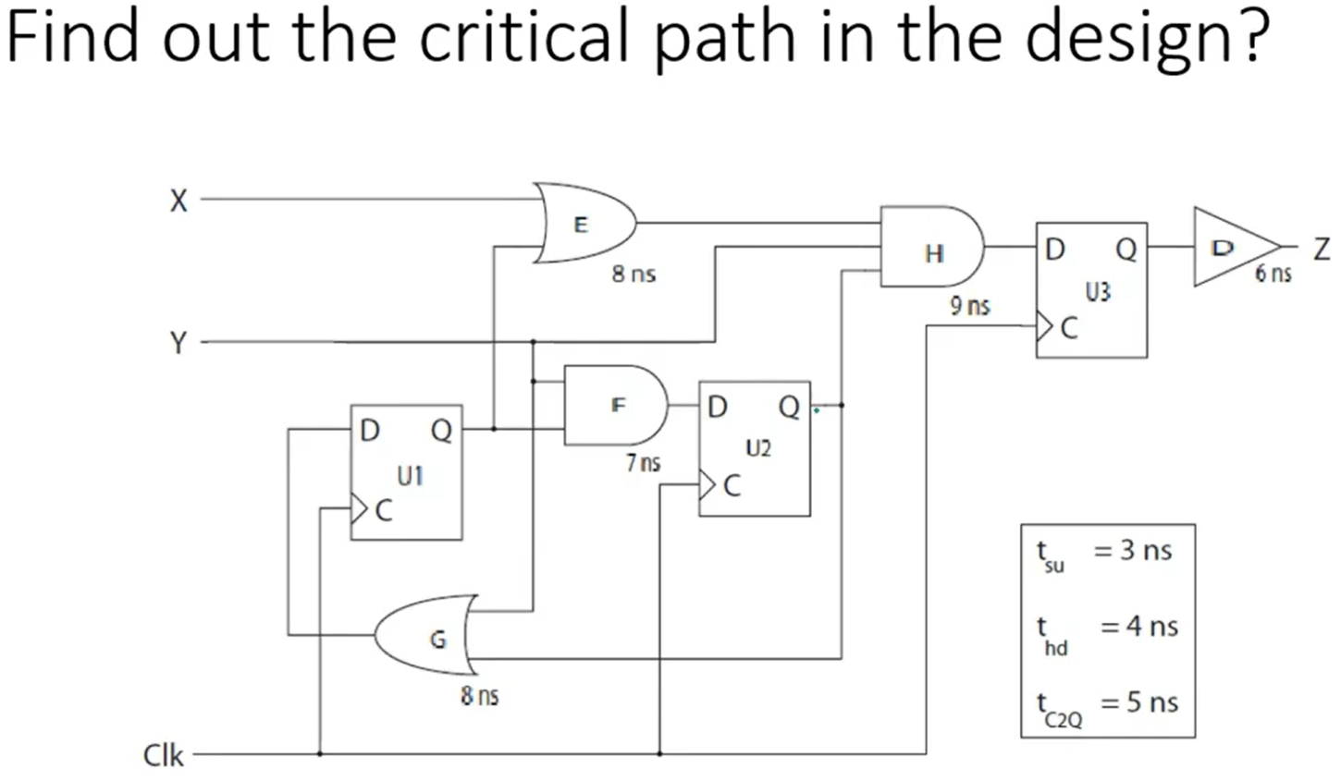
Answer:
The critical path is the longest path between 2 flip flops. Thus, trace every path between each 2 flip flops and you will find that the critical path is from flip flop U1 E H U3.

----------------------------------------------------------------------------------------------------------------------------------------------------------
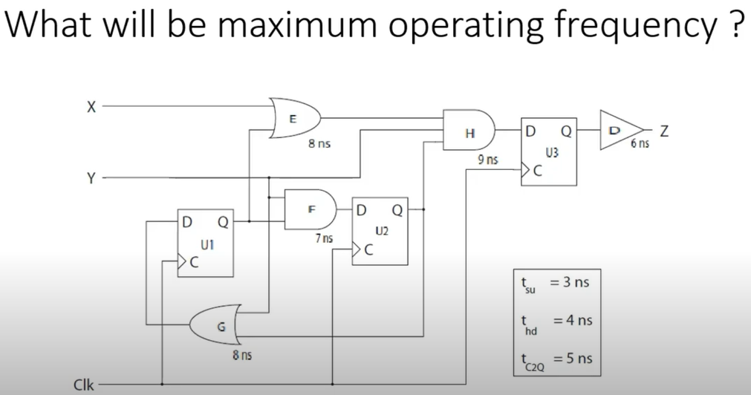

Answer:
Doing setup analysis on the critical path:
$$t_{c2Q}{\left.​\right|}_{U1}+t_{pd}{\left.​\right|}_{E}+t_{pd}{\left.​\right|}_{H}<T_{clk}-T_{su}$$
$$T_{clk}{\left.​\right|}_{min}=25 ns$$
$$f_{max}=\frac{1}{25 ns}=40 MHz$$
----------------------------------------------------------------------------------------------------------------------------------------------------------

In the previous design, what will happen if the design is operated at a frequency higher than the maximum operating frequency?

Answer: setup time violation will occur on flip flop U3 and hence it will become meta-stable.

----------------------------------------------------------------------------------------------------------------------------------------------------------
What type of violation does not depend on the operating frequency?

Answer: hold time violation.
----------------------------------------------------------------------------------------------------------------------------------------------------------
Give an example of a design that is prone to hold time violation.

Answer: shift registers and synchronizers.
In general, designs with less combinational logic path delay between flip flops are prone to hold violation.

----------------------------------------------------------------------------------------------------------------------------------------------------------
Give an example of a design that is prone to setup time violation.

Answer: counters.
In general, designs with more combinational logic path delay between flip flops are prone to setup violation.

----------------------------------------------------------------------------------------------------------------------------------------------------------

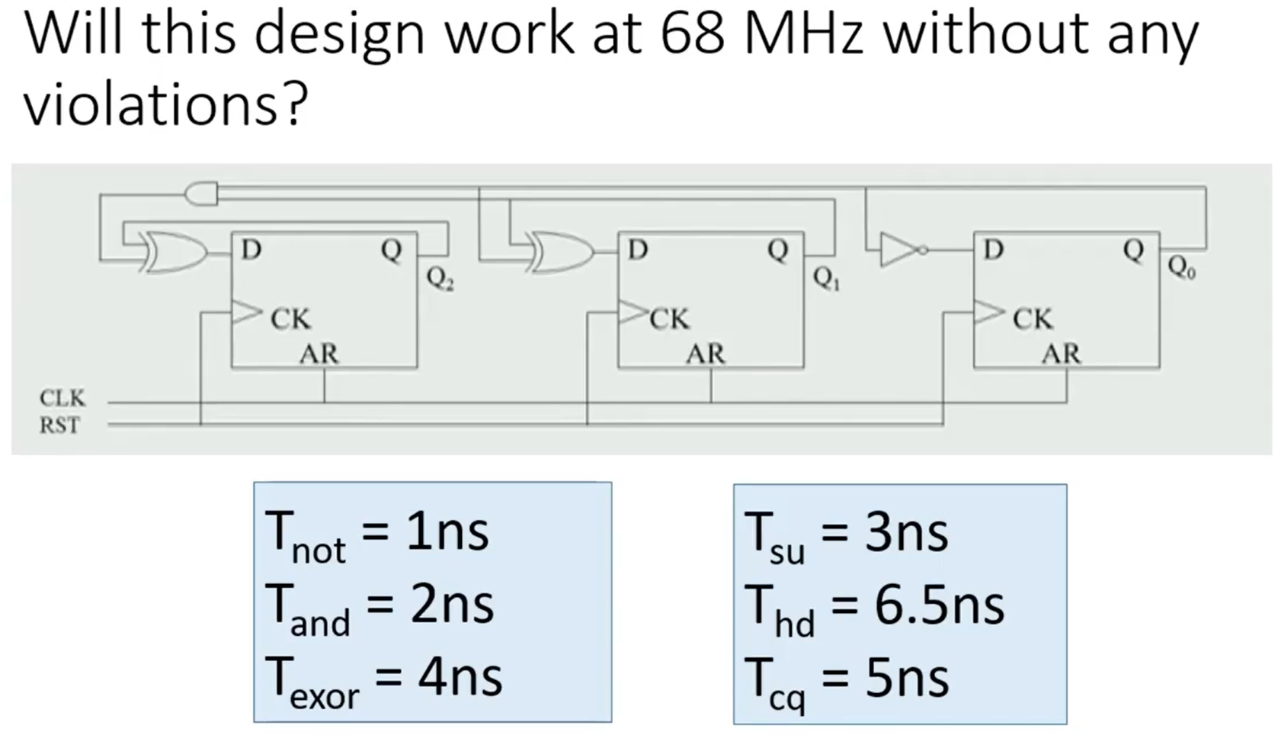
Also, determine the slack of his design (whether positive or negative).
Answer:
First, el time el momken ye7sal violation fih besabab el frequency howa el setup time. Thus, me7tagen n3ml setup analysis. 3ashan ne3mel setup analysis, met7agen ne decide el critical path. El critical path beyeb2a maben 2 flip flops. Trace el output bta3 kol flip flop l7d el flip flop el tany, hatla2y el critical path howa men Q1 to D2 as well as Q0 to D2, el etnen zy b3d. Tab3an howa el manteqy en Q0 to D2 yeshoof wiring delay akbar w yeb2a howa el critical path bs howa mesh 2ayel ay wiring delays fa 5alas yeb2a ay wa7ed fihom howa el critical path. Now, apply setup analysis:
$$T_{cq}+T_{AND}+T_{XOR}<T_{CLK}-T_{su}$$
$$T_{clk}{\left.​\right|}_{min}=14 ns→f_{max}=71.4 MHz$$
Thus, no violation at $f=68 MHz$.
Slack = required time – arrival time = ($T_{CLK}-T_{su}$) – ($T_{cq}+T_{AND}+T_{XOR}$) = ($\frac{1}{68 MHz}-$3) – (5+2+4) = +0.7 ns.

----------------------------------------------------------------------------------------------------------------------------------------------------------
Do hold time violation check for the previous design.

Answer:
To do hold time check, we need to find the path with least delay between 2 flip flops. It is from Q0 to D0.
$$T_{cq}+T_{NOT}>T_{hold}$$
$$5+1>6.5$$
$$6>6.5 X$$
Therefore, there is a hold time violation with slack = -0.5 ns.
----------------------------------------------------------------------------------------------------------------------------------------------------------


Answer:
By introducing positive skew, the maximum operating frequency will increase.
----------------------------------------------------------------------------------------------------------------------------------------------------------


Answer:

By introducing positive skew, chances of hold violation increase.

----------------------------------------------------------------------------------------------------------------------------------------------------------
Which violation is more dangerous; setup or hold violation?

Answer:

Hold violation is more dangerous than setup violation. Watch video 3. El kalam el ba2olo fel video ba2olo men weg-het nazar wana lesa a3ed ba design, lesa el chip matsana3etsh. Laken 7ata b3d ma el chip tetsana3, fa el hold violation howa bardo el a5tar bekteer men el setup violation. Leeh? La2en delwa2ty el chip gatly w mesh shaghala. Ro7t garabt a2alel el frequency el ana shaghal beha fa el chip eshtaghalet. Yeb2a keda el chip makanetsh shaghala fel awel leeh? 3ashan kan fih setup violation. Fa hena 2edert a3raf en el moshkela kanet setup violation. Laken lw el moshkela kanet hold violation 3omrak ma hate3raf. Leeh? La2en el chip gatly delwa2ty w mesh shaghala. Garabt a2alel el frequency mashtaghaletsh, yeb2a mesh setup violation. Oly b2a hat test ezay eno hold violation wala la2? Mesh hate3raf! 7al el hold eny azawed el delay beta3 el paths, w da kan abl el fabrication, el chip etsana3et 5alas, w bel taly mesh ha2dar a3raf eza kanet mesh shaghala besabab en fih hold violation wala fih mask et3amal ghalat athna2 el fabrication wala ay 7aga tanya. 7al momken yetgarab bs mesh controlled 5ales w howa enak tegarab tesa5an w tebarad el chip. Lw eshtaghalet masalan w heya so5na fa da kan hold violation la2en el temperature el zeyada de hat5aly el delays tezeed, w bel taly lw kan hold violation fa hayet7al. Bs da 7al mesh controlled la2enak mesh 3aref bzbt zeyadet el temperature hatzawed el delays 2ad eh, fa momken tezeed awy le daraget eno ye2leb setup violation, da gheer en akeed sa3b tozbot el temperature bta3t el chip bzbt (I think y3ny).

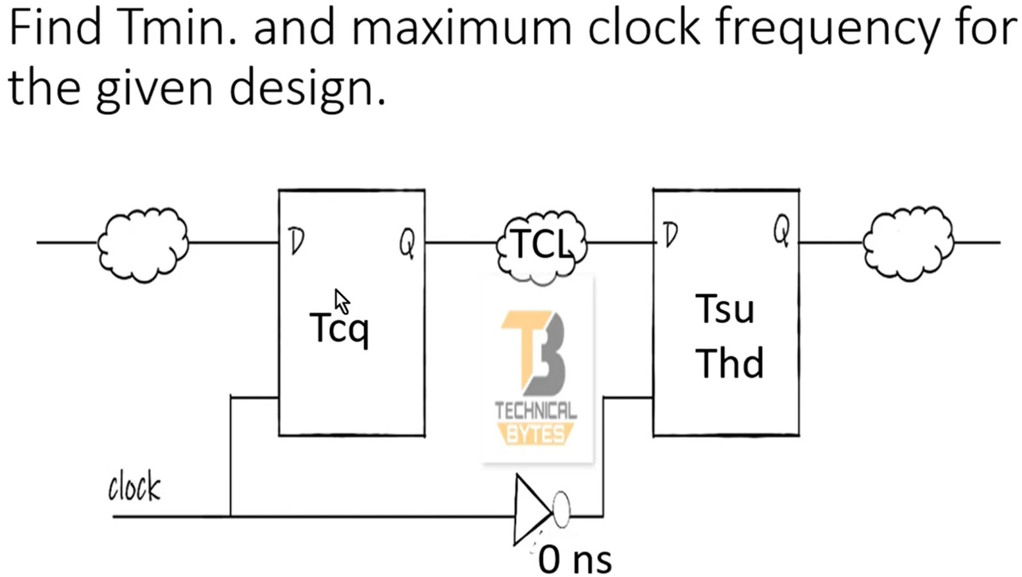
Answer:
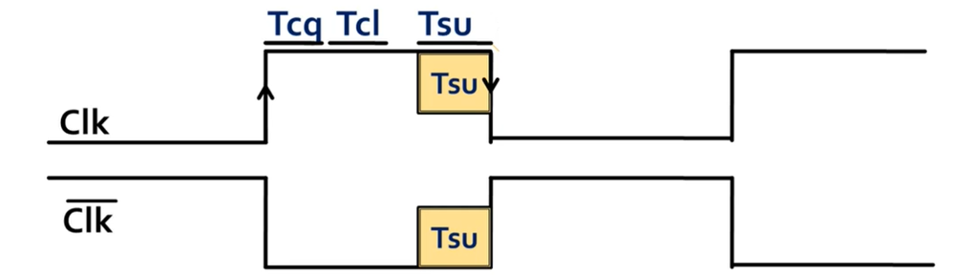

$$T_{cq}+T_{cl}<\frac{T_{clk}}{2}-T_{su}$$
$$∴T_{clk}{\left.​\right|}_{min}=2\left(T_{cq}+T_{cl}+T_{su}\right)$$
----------------------------------------------------------------------------------------------------------------------------------------------------------
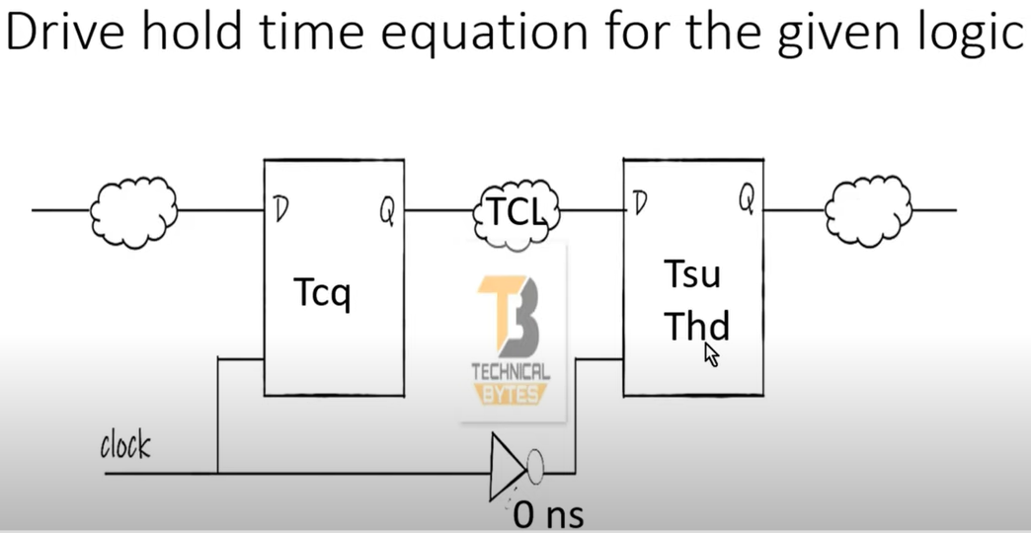
Answer:
$$T_{cq}+T_{CL}>T_{hold}-\frac{T_{clk}}{2}$$
Watch video 4.

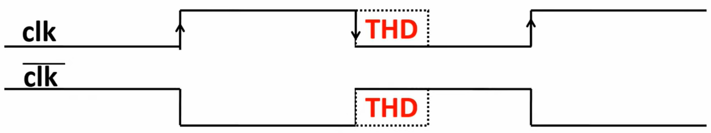

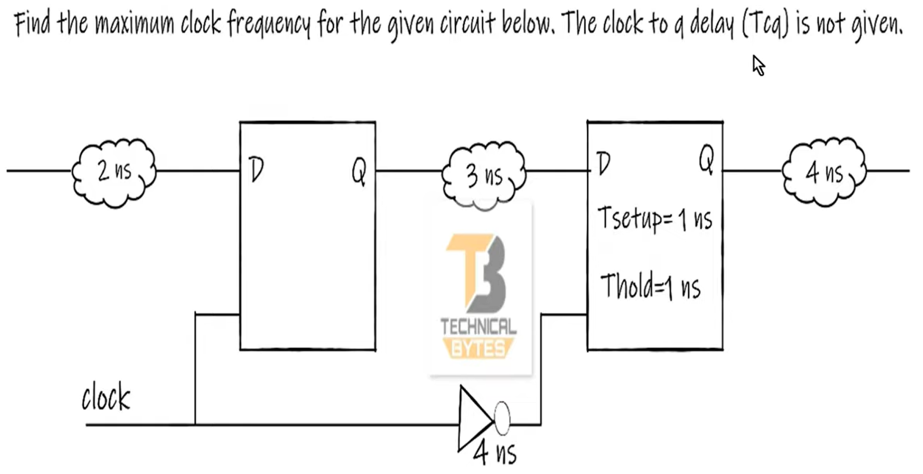
Answer:
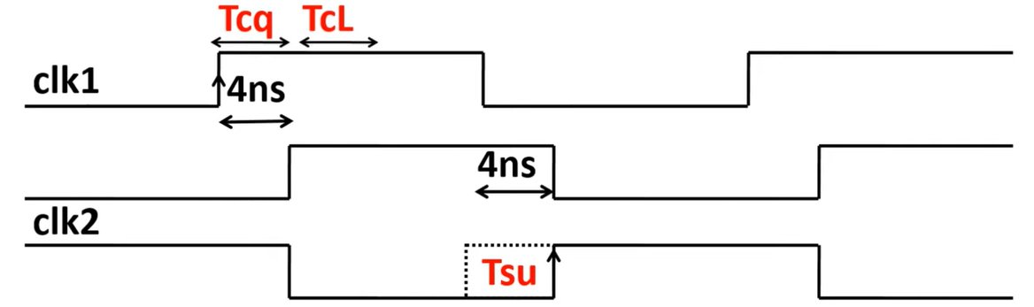
$$T_{c2q}+3<4+\frac{T_{clk}}{2}-1$$
$$T_{clk}{\left.​\right|}_{min}=2*T_{c2q}$$
Watch video 5 for more illustration.
----------------------------------------------------------------------------------------------------------------------------------------------------------
Why is it called “static” timing analysis?

3ashan el analysis beytem fe3lan be tare2a statically, el synthesis tool mesh bete3mel simulation, y3ny mesh bet apply inputs w tshoof el delay 2ad eh, la2 heya betshoof el path da fih gates eh w troo7 tegeeb el worst-case delay bta3 el gates de men el library el slow-slow (typical-typical lw enta mesh 7atet slow-slow y3ny).

---------------------------------------------------------------------------------------------------------------------------------------------------------
Do we check our design functionality in static timing analysis?

No, el STA maloosh ay 3elaka bel functionality. In fact, el phase bta3t el synthesis tool kolaha malhash ay 3elaka bel functionality, e7na da5leen ne check el time w netala3 reports el power wel area w nerawa7.
For the shown circuit below, assume the input delay constraint is 0.3 ns. Also, assume the setup time for both flops is 0.4 ns. How many timing paths will the STA tool (e.g. PrimeTime) analyze? What are the types of these paths? Which path limits the maximum frequency?

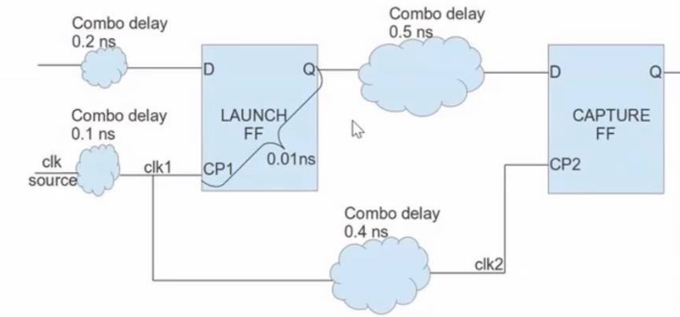
Answer:
- There are two paths.
- Their types:
- Input-to-reg path.
- Reg-to-reg path.
- For max frequency, we do setup analysis:
$$arrival time<required time$$
For input-to-reg path:
$$0.3+0.2<T_{clk}-0.4+0.1\left(skew\right)$$
$$T_{clk}>0.8$$
For reg-to-reg path:
$$0.01+0.5<T_{clk}-0.4+0.4(skew)$$
$$T_{clk}>0.51$$
Thus, input-to-reg path limits the maximum frequency = $\frac{1}{0.8 ns}=1.25 GHz$
---------------------------------------------------------------------------------------------------------------------------------------------------------
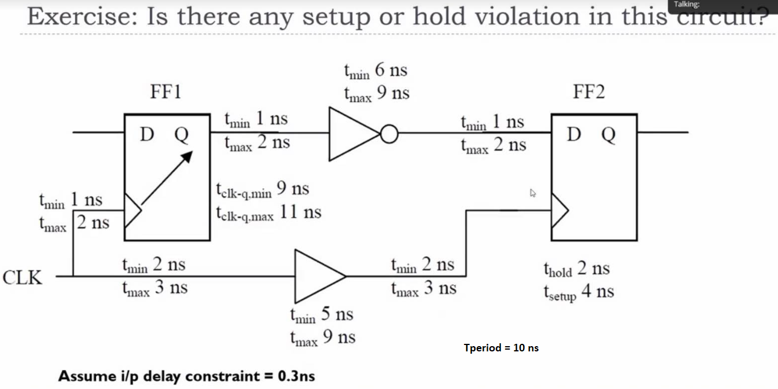
- Reg-to-reg path:
- Setup analysis:
$$arrival time<required time$$
Bema eno medeny maximum w minimum time le kol 7aga, fa wana ba7seb ha5od dayman el yedoreny aktar. Fa ha5od el yekabarly el arrival time:
$$11\left(t_{cq}\right)+2\left(wiring\right)+9\left(not\right)+2\left(wiring\right)<10\left(t_{clk}\right)-4\left(t_{su}\right)$$
El skew bkam? Ana 3aref en fel setup el positive skew howa el beyfedny, w bel taly ha7awel a5od el ye5aly el skew as small as possible. Tyb howa el skew equal kam?
$$T_{skew}=T_{\begin{aligned}clk arrival \\ @ capture flop\end{aligned}}-T_{\begin{aligned}clk arrival \\ @ launch flop\end{aligned}}$$
$$∴T_{skew}=\left(2+5+2\right)-\left(2\right)=7 ns$$
Tl3 positive skew bardo. Y3ny fel worst case bardo el skew beysa3ed el setup. Nerga3 nedeefo 3al equation b2a:
$$11\left(t_{cq}\right)+2\left(wiring\right)+9\left(not\right)+2\left(wiring\right)<10\left(t_{clk}\right)-4\left(t_{su}\right)+7(T_{skew})$$
$$24<13→setup violation$$
- Hold analysis:
$$arrival time>required time$$
Hena b2a ha5od el ye2zy el hold, y3ny el ye5aly el arrival time asghar 7aga momkena.
$$9\left(t_{cq}\right)+1\left(wiring\right)+6\left(not\right)+1\left(wiring\right)>2\left(t_{hold}\right)$$
Now ne7seb el skew. El negative skew howa el beyfedny, yeb2a a7awel a5od el ye5aly el skew as large as possible.
$$T_{skew}=\left(3+9+3\right)-\left(1\right)=14 ns$$
Nezawedha 3al equation:
$$9\left(t_{cq}\right)+1\left(wiring\right)+6\left(not\right)+1\left(wiring\right)>2\left(t_{hold}\right)+14(T_{skew})$$
$$17>16→no hold violation$$

Clock Domain Crossing

- Emta n2ool 3la 2 clocks enohom asynchronous?

Lama ykono generated from 2 different clock sources.

----------------------------------------------------------------------------------------------------------------------------------------------------------

- Emta yd5ol el flip flop fi metastability?
Lama y7sl setup/hold time violations.

----------------------------------------------------------------------------------------------------------------------------------------------------------

- Hal b3d ma esta5demna synchronizer keda mesh haye7sal metastability tany?
No! el synchronizer hay5aly el MTBF kebeer gedan gedan, laken mesh infinity. In other words, using a synchronizer decreases the probability of metastability tremendously, but never zero.

----------------------------------------------------------------------------------------------------------------------------------------------------------

- Draw a block diagram for a pulse generator.
Answer in assignment 1.1 CDC.
----------------------------------------------------------------------------------------------------------------------------------------------------------

- Eh heya wazefet el reset synchronizer?
eno ye5aly:
1) Asynchronous reset assertion.
2) Synchronous reset de-assertion.

Synthesis
What is logic synthesis?
The synthesis tool takes 3 inputs:
1) RTL files.
2) Technology files.
3) Constraints files.
and gives one output:
1) Technology-dependent gate-level netlist.
Kol el l synthesis tool hate3melo howa enaha hata5od menak .v files w tetala3lak .v file bardo. El da5el howa el RTL bta3ak, bs el 5areg howa "gate-level netlist". Y3ny eh? y3ny el synthesis tool hatbos 3la kol goz2 fel RTL code beta3ak w tshoof te2dar te3melo mapping le gate eh fel technology files el enta medehalha. Enta masalan kateb line of code fih AND gate zy a = b & c, el tool hatroo7 shayla el line da w 3amla badalo instantiation le AND gate mawgoda fi el technology files el enta medehalha. Fa de ahameyet el technology files ka input. Bs delwa2ty el technology files de fiha aktar men AND gate, be ma3na fiha AND gates leha different sizes (X1, X2, etc.) w different Vth flavors (high Vt, low Vt), fa te5tar anhy gate? de b2a ahameyet el constraints file ka input, el tool hatebda2 te optimize fi el gate-level netlist de according lel constraints file. Masalan enta 2ayelha 3ayez el design yeshtaghal 3la 10 MHz, ra7et e5taret gates mo3ayana men el technology files beta3tak w b3d ma 5allaset la2et eno lesa mesh me7a2a2a el frequency de. T3ml eh? troo7 shayla masalan el AND gate el leha size X1 w t7ot badalha X2 3ashan te2alel el delay, aw t7ot wa7da tanya leha low Vt masalan b7ees bardo te2alel el delay (tab3an el mawdoo3 mesh bel basata de, el mawdoo3 mortabet bel logical effort equation, fa el synthesis tool betnafez el logical effort equation 3ashan te3raf el optimum sizing le kol gate fel chain). Tyb b3d ma 3amalt da kolo w 5alaset ektashafet masalan eno fih slack kebeer, fih +5 ns slack fel critical path masalan. T3ml eh? t2olak 5alas madam el denya meraya7a keda ana kont 7atta hena gate leha driving strength X4, la2 5alas t3ala nesheel el X4 de w n7ot badalha X1 kefaya, b7ees a2alel el area shwaya and hence a2alel el power. Tab3an da hayzawed el delay bs mesh moshkela mana 2ased aslan azawed el delay moqabel eny awafar shwaya fel area wel power bema eny keda keda m3aya slack kebeer, fa el slack ye2el shwaya mesh moshkela.
----------------------------------------------------------------------------------------------------------------------------------------------------------
Why do we perform logic synthesis before PnR, why not PnR directly?
Because the synthesis tool generates a gate-level netlist that is required by the PnR tool. That is, the synthesis tool maps your RTL code into actual gates in your technology files in the form of a gate-level netlist, which is simply an RTL file instantiating gates from your technology files. The PnR tool can't do this, it just takes a netlist of gates and place & route it. Thus, it is a must to perform logic synthesis for technology mapping before PnR.
----------------------------------------------------------------------------------------------------------------------------------------------------------
Leeh bene3mel timing analysis b3d el logic synthesis, ma7na keda keda hane3mel b3d el PnR w 7ata yeb2a more accurate w bey include el routing delays?
Bene3mel timing analysis during el logic synthesis 3ashan ne make sure en mafeesh ay setup violations mawgooda b3d el synthesis, la2en lw fi ay setup violations b3d el synthesis, fa definitely hayeb2a fih setup violations b3d el PnR as well. Leeh? la2en 5aly balak en el 7aga el wa7eda el beta5talef mabeen el synthesis wel PnR heya el delays bta3t el routing. Fanta lw fi path masalan fih 3 multipliers wara b3d w zahar eno fih setup violation fel timing analysis el athna2 el synthesis, fa el path da hayeb2a bardo mawgood fel PnR mesh haye5tefy, y3ny el 3 multipliers dool hayefdalo wara b3d bardo 3ady ayan kan eh el placement el haye7salohom, mesh hayezhar pipelining registers fag2a benhom fel PnR, bal eno hayetdaf 3al path da el routing delays kaman el mabeen el 3 multipliers dool, fa definitely haye7sal setup violation b3d el PnR madam 7asal b3d el setup.
----------------------------------------------------------------------------------------------------------------------------------------------------------
Leeh ben7ot timing constraints during el logic synthesis, mesh el mohem eny a7otohom sa3et el PnR bs b7ees el tool t7awel te place w te route such that enaha te meet el timing constraints de, eh ahameyet el timing constraints de bel nesba lel synthesis tool?
Ben7ot timing constraints during logic synthesis 3ashan ne force el synthesis tool to try to optimize as much as possible in the synthesized netlist for the given timing constraints. Y3ny eh? delwa2ty e7na bena5od el synthesized netlist de nedeha lel PnR tool te3melaha placing and routing bs, laken mesh fi edeha enaha teghayar el sizes bta3t el gates la2en 5alas el netlist tel3et w ma3mool fiha instantiation le gates leha driving strength mo3ayan, el fi edo yeghayar el sizes de kan el synthesis tool. 7aga tanya bardo w heya e5tyar el threshold voltage bta3 kol gate, momken hena asta5dem low Vt aw asta5dem high Vt, fa de 7aga el synthesis tool heya el hate5tarha el PnR tool mate2darsh teghayarha, fa bardo el e5tyar hena lazem yeb2a optimized for some constraints. Fa momken el PnR tool te optimize be a7san tare2a momkena bel nesbalha, laken te fail timing mesh besababha heya w enama besabab en el netlist el gayalha mesh optimized. Fa7na lw sebna el synthesis tool te synthesize men gheer ay timing constraints, hat7ot ay gates be ay sizes w ay Vt flavors w 5alas. Laken lama yeb2a fih timing constraints, hatebda2 b2a t7awel te5tar sizing mo3ayan such that enaha te meet el timing requirements de. Masalan t2ool la2 hena X1 mesh hatenfa3 ana hasta5dem X2, hena low Vt mesh high Vt 3ashan a2alel el delay, and so on.
----------------------------------------------------------------------------------------------------------------------------------------------------------
Ezay el synthesis tool bete2dar te3raf el propagation delay wel power btoo3 standard cell mo3ayana fel library?
Answer: using the “non-linear delay model”, which is a model that uses a circuit simulator to characterize a cell’s transistors with a variety of input transitions and load capacitances and record the results in a table. Y3ny eh characterize el cell’s transistors? y3ny benekteb fel table da en given el input transition lel cell kan kaza wel load capacitance kan kaza, el propagation delay wel power wel output transition btoo3 el cell de hayeb2o kaza. Tyb wel tool hatgeeb el input transition beta3 el cell menen? men el output transition beta3 el gate el ableha. W hatgeeb el load capacitance menen? men el input capacitance bta3 el gate el ba3deha.

----------------------------------------------------------------------------------------------------------------------------------------------------------
What is meant by operating conditions?
Answer:
El ma2sood bel conditions de heya PVT, w homa process w voltage w temperature, w de conditions bet2asar 3al operation bta3t el IC la2enaha betghayar fi el delay bta3 el circuits as follows:
1. Process: ma2sood beha en ye7sal variations athna2 el fabrication bta3 el chip zy en ye7sal taghyeer fel doping masalan. Da hay2asar fi eh? hay2asar 3al NMOS wel PMOS transistors el mawgodeen fel design, fa momken yetla3ly fast-fast chip aw slow-slow chip. Y3ny eh fast-fast w slow-slow? y3ny lama geet a3mel fabrication, due to some variations in the fabrication process, el NMOS wel PMOS transistors tel3o faster aw slower than expected., w sa3et-ha tab3an hab2a 5ayef men el fast-fast wel slow-slow corners fi el hold wel setup violations.
2. Voltage: en el supply voltage ye7sal fih variations, w el current is function of el voltage, fa lw el voltage 2al masalan el current hay2el and hence el delay hayzeed.
3. Temperature: en el chip el temperature beta3et-ha tetghayar athna2 el operation, w el threshold voltage is a strong function in the temperature, fa lw el temperature zadet el threshold voltage hatzeed and hence el delay hayzeed.
Accordingly, beyeb2a fih 3 versions men el standard cells library:
1. Typical library.
2. Slow library.
3. Fast library.
When passing the three libraries to the synthesis tool, el mafrood enaha testa5dem arqam el slow library fel setup analysis w arqam el fast library fel hold analysis.
----------------------------------------------------------------------------------------------------------------------------------------------------------
what is the designWare library?
Answer: it is an IP library provided by Synopsys that contains different IPs, similar to the idea of IP catalog of Xilinx Vivado.
----------------------------------------------------------------------------------------------------------------------------------------------------------

What is the difference between static timing analysis and dynamic timing analysis?
Answer: abl ma negaweb 5alena n2ool en there are two types of simulations:
- RTL-level simulation: el bene3melo fel awel 5ales 3la el RTL nafso w no3od ne debug w net2aked en el design shaghal sa7 3al waveform w keda.
- Gate-level simulation: el bene3melo 3la netlist, sawa2 kanet 5arga men synthesis, DFT, or PnR.
El gate-level simulation nafso b2a fih two types of simulations:
- Functional simulation: no timing information is included w kol 7aga ideal w el signals betetla3 w tenzel ideally men gheer ay delay.
- Timing simulation: timing information is included w bete2dar teshoof el propagation delays wel $t_{cq}$ and so on 3al waveform.
Tab3an you saw all these types of simulations 3la Vivado.
Tyb eh b2a el far2 been el STA wel DTA? el STA howa el analysis el bete3melo tool zy primeTime bta3t Synopsys, w heya enaha tebda2 te3mel setup analysis w hold analysis le kol el paths el mawgoda fi el design 3an taree2 enaha tetaba2 el equation bta3t el setup analysis wel hold analysis, w betgeeb arqaam el delays bta3t el different gates and flip flops men el .lib library. El DTA b2a on the other hand ben refer leeh also as simulation-based timing analysis, w howa ta7dedan enena ne3mel timing simulation (i.e. not functional simulation) 3ala netlist tal3alna w nshoof el delays 3la el waveform. Here is the full comparison:
Static Timing Analysis (STA) | Dynamic Timing Analysis (DTA)
No input stimulus. | Input stimulus provided.
Validates timing only not functionality. | Validates timing and functionality.
Much faster than DTA. | Much slower than STA.
Complete and exhaustive process. | Analysis quality depends on stimulus vectors.
Verifies synchronous logic only. | Can verify both synchronous and asynchronous logic.

----------------------------------------------------------------------------------------------------------------------------------------------------------

Meen el bey7aded el supply voltage, el system engineer wala el technology el benesta5demha (el heya bey7adedha el customer)?

Answer: technology. Leeh? la2en zy ma olna fi course Dr. Hesham en fih 2 electric fields fel MOSFET:
1) Vertical field: maben el gate wel substrate. E = V / t_ox.
2) Horizontal field: maben el drain wel source. E = V / L.
W m3 el scaling down el by7sl lel transistor, fa el t_ox wel L bey2elo fa el fields de betzeed. W kona olna en zeyadet el fields de bete3emel mashakel keteer, el heya el high-field effects. Fa7na 3ashan ne preserve "constant-field scaling", e7tagna en el V kaman te2el. W bema enena fel digital shaghalen be 0 w VDD bs, fa el V hena howa el VDD, fa el VDD kaman me7tag yet3emelo scaling down. Thus, el technology faradet 3alaya eny a3mel scaling down lel supply voltage, mesh be mazagy, mayenfa3sh agy asta5dem technology gededa zy el 7 nm masalan w a2ol hashtaghal be VDD 5V.

DFT

PnR

Miscellaneous
What are the benefits of integrating all more components into a single chip, moving system blocks from board level to chip level? [cost, performance, power].
Answer:
Cost: less
Performance: better
Power: less
Elaboration:
Cost & Area: en ana asana3 chip wa7da gowaha kol 7aga awfar w a7san fel area bekteer men eny asana3 kol unit fi chip lwa7daha. Leeh? men demn el factors masalan, kol chip betetsana3 beyeb2a leha "package" betet7at fih fel a5er. Fa lw 3andena 5 chips, hayeb2a 3andena 5 packages bel area wel cost beta3et-hom. Laken lw 3amalna integration fi chip wa7da, 3adad el packages hay2el and hence el area wel cost hay2elo. Tab3an el integration beywafar fel area wel cost in general mesh bs 3ashan el package, da just factor men demn factors keteer. For example, Apple bet7awel te integrate el processor wel fan wel graphics card w ... kolo 3ala chip wa7da.
Power: lama yeb2a kolo 3la chip wa7da, mesh ha7tag communication blocks mabeen el chips el keteer de and hence el power hay2el.

- 7ot el pulse generator wel clock divider fel interview questions file! For the clock divider, fih two cases:
i. En el divide ratio tkoon pre-known and always constant, w bel taly sa3et-ha hayeb2a el hardware configurable w beyetghayar
3la asas el parameterized divide ratio: https://www.youtube.com/watch?v=AfINILc0WEg
ii. En el divide ratio tkoon un-known aw betetghayar kol shwaya, w bel taly sa3et-ha lazem el hardware hayeb2a sabet w bey
support ay division ratio, w da el e7na already 3amalnah ma3 Temsah.
Yeb2a check chapter 4 fi "the art of hardware architecture" book: https://drive.google.com/file/d/16Y2_6JcJX_qwsHLnZz-p3Ut68k0PSU7k/view
- Watch NajahNow & integrate these 2 periods:
i. Session 1: 58:45 to 1:18:17
ii. Session 2: 1:48 to 1:14:40
Add any questions in the interview questions file at the end.
- VLSI Community (https://drive.google.com/drive/u/0/folders/1xybxKdevnhAntzfM2v-YcEjSUZLvNtxI): da3best fih shwaya. 7ases mo3zam el material we already covered, fa momken el yeb2a kwayes fih el interview questions.

